BASE CAMP
1890 Highland Drive, Zillah
BCHW WINERY RIDE FREQUENTLY ASKED QUESTIONS

PRE-RIDE:
- Our event Base Camp location is 1890 Highland Drive Zillah WA. See our website for updated driving directions and map. **Note some mapping aps take you the wrong way!**
- To guarantee a camping spot pre-registration is required for either Friday or Saturday nights. Do not arrive prior to 10:00 AM on Friday as our crew may not be ready to receive you.
- There will be a $15 service fee for any refund requests.
- In response to several inquiries, Hart Ranch at 151 Ray Symmonds Rd. does overnight boarding of horses. Sue Hart can be reached at 509-952-8792. BCHW has no affiliation with this facility. This is just information as a courtesy.
CAMPING:
- Camping spots/locations are filled in order of arrival. No reserves, no saving spots for later arrivals. If you want to camp together, arrive together. No exceptions.
- Only one camp spot may be reserved per vehicle combination (truck & trailer/Motorhome, etc.). Exceptions are if you have more riders in your party than your truck will accommodate, i.e., a second car parked in your camping spot is acceptable, but a second horse trailer is not.
- Each camp spot at the base camp is 30-ft wide x 70-ft long This size will handle large living quarter trailers and your portable corrals.
- You will have to provide your own temporary corrals (electric or panels) or tie to your trailer. There are no high lines or stalls (or trees). The camp area is a hay field. No unattended stock may be left on-site
- A 10 ft. emergency lane on the right side of your vehicle MUST be kept open. Do not extend your corrals or other items into this safety lane.
- Only registered participants may park on the camping property during this event. Each registered vehicle must place their parking pass in the windshield of the vehicle. Vehicles without a parking pass may be towed and impounded at the discretion of the property owner.
- Stock water is available at the camping area. We typically have 3 individual watering stations situated at various locations around the camping area. You will need to bring your own water buckets as there will be no water troughs provided. Each watering station location will have a faucet to fill your own buckets.
- Chemical toilets are available for campers and registered riders
- Camp cooking: only propane grills and propane fire pits allowed. NO WOOD FIRES
- Quiet time. Turn off generators and loud noises at 10:00 PM
- For use of this property, campers are asked to clean up their campsites by taking any wasted hay or bedding home with them if they can. Manure can be dispersed around your site or thrown into the fire lane if you are not willing to haul it home. DO NOT DUMP MANURE IN GARBAGE DUMPSTERS. BCHW believes in LEAVE NO TRACE. Please practice this.
- Dogs must be on a leash when leaving your camp site. Dogs are not allowed in registration area or on the trails.

IT'S ALL ABOUT THE RIDE:
- Length of ride is up to riders, with two different loops to choose from. Our West loop runs a total of 12-miles, or about 4 to 5 hours ride. The East loop totals 8-miles or 3 to 4-hours riding if ridden straight through with no stops. The West loop has a shorter optional route for those wishing to cut down the mileage. Maps will be available at the BCHW Information Booth.
- Each rider determines their time on the trail by the amount of time they spend at each winery and their horse’s pace. There’s ample opportunity to spend plenty of wine tasting time. Riders go out as early as 9:30 am and return as late as 5:30 pm, at their discretion. Please be back before dark for your safety! Take your plastic wine glass with you to the wineries.
- Terrain is mostly even with some low rolling hills. This is farm/orchard country (and vineyards, of course). Mostly dirt, some gravel, some pavement (short distances).
- There can be up to a total of 12 participating wineries, if all owners again choose to participate. An average of 6 wineries are on each loop depending on participation. (3 of them are on both loops).
- Some wineries have hitch rails; some have trailers to tie too. At times these wineries can get very crowed and you will either need to wait for a tie spot or you will need to share horse holding duties. Please do not tie to trees or grape posts.
- If your horse is prone to kicking in tight situations, please tie a red ribbon on the tail.
- Please respect the wineries business Do not consume any alcohol other than wine purchased specifically from that winery while on their property. Violating this may cause the wineries to have their license revoked or fined by the State of Washington.
- Some of the wineries do charge a tasting fee. This fee is separate from ride fees, meal costs, etc. and does not go to BCHW.
- Wear your rider number so that it is always visible. This establishes your legitimate right to be on the winery property.
CAMP DINNERS:

- Friday: there will be a Taco truck on site, Takicardia with Burritos, Quesadillas, Taco’s and more. 10am-10pm
- Saturday Morning: Breakfast Burritos
- Saturday Night: You are on your own for dinner.
- Pizza Hut, which is within a mile from camp will deliver. 509-829-6137

WINE PICK UP AND PRIZES:

All wine and prizes must be picked up by 8:00 PM on Saturday.

- Most wineries are closed by 6:00 PM and we do our best to have all wine ready for pick up by 6:30 PM.

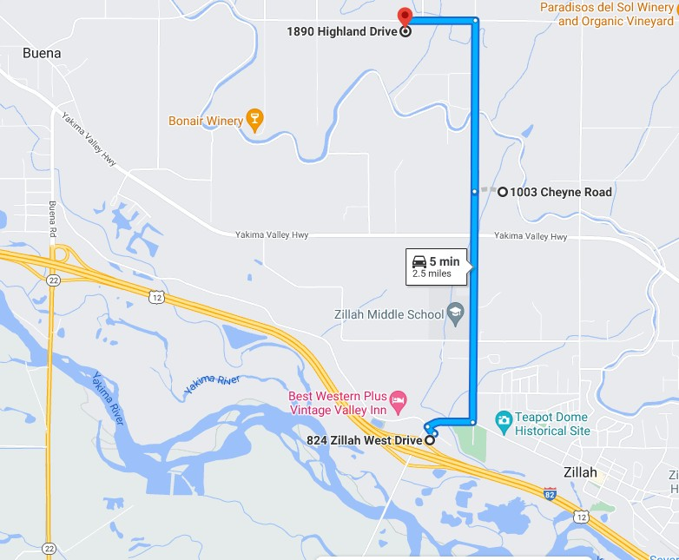
5 minutes from the freeway!

DIRECTIONS TO 1890 HIGHLAND DRIVE / BASE CAMP
Traveling East on I-82 (from Seattle/Ellensburg/Yakima), take Exit 52 toward Zillah. Turn Left on Meyers Rd. Take the 2nd Left onto Cheyne Road. Continue on Cheyne past the school and through stop sign at Yakima Valley Hwy. Continue North approximately 1-mile, then turn left on Highland Drive. Go just under ½ mile to just past 1890 Highland Drive to the very next driveway on the South side.
Traveling West on I-82 (from Walla Walla/Tri-Cities/Sunnyside), take Exit 52 toward Zillah. Turn Right on Meyers Rd. Take the 2nd Left onto Cheyne Road. Continue on Cheyne past the school and through stop sign at Yakima Valley Hwy. Continue North approximately 1-mile, then turn left on Highland Drive. Go just under ½ mile to just past 1890 Highland Drive to the very next driveway on the South side.

