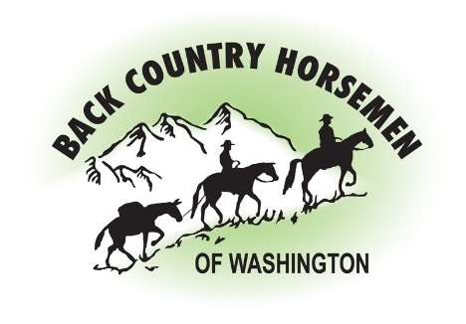
BACK COUNTRY HORSEMEN OF WASHINGTON
PO Box 1132
ELLENSBURG, WA 98926
WWW.BCHW.ORG

Feb 23, 2022

Thank you for the opportunity to provide feedback on the Draft 10 Year Recreation Strategy.

Fishing, hunting, habitat protections and developing and maintaining diverse fish and wildlife populations is WDFW’s mandated mission. Back Country Horsemen of Washington (BCHW) appreciates this current effort that WDFW is making to recognize, educate and manage the influx of people that are coming to WDFW lands to enjoy other types of recreation. BCHW views this initial discussion of the 10-year plan as the implementation of a vision that when finalized will be a “living and changing” document as different components of the plan are implemented; and that each aspect will be further subjected to data collection, science, public and tribal input, and prioritization.

As stock users we are concerned when changes affect our ability to continue to access and enjoy recreating on WDFW lands. As shown on the chart presented with the plan, equestrians represent the smallest group of users, at 6%. We recognize that the perception of stock use is visually larger to others. As the smallest user group, we are concerned about being painted with the same broad brush as other users. First, we need to point out that horses and mules are not disruptive to wildlife. Stock users most often observe wildlife without disturbing them. Second, BCHW was created to advocate for stock access to public lands and to assist public agencies in caring for and maintaining those lands. BCHW members are available as volunteers, stewards and educators to help WFDW keep these public lands accessible to stock and to other recreational users.

We believe that the highest priority and the first steps in implementing this plan should be education. Education provides a foundation of knowledge that is then built upon as other components are introduced.

BCHW supports the development of a mapped trails system on WDFW managed lands. Trails that are designed and signed will accommodate many, perhaps most users. Development of signage and signage guidelines are valuable near-term actions that should be implemented. Signs can be aids for route finding and for education and information about the lands being traversed.
BCHW will object if stock use is limited to trails, without careful evaluation of impact on wildlife in specific areas. The ability to travel cross country and the opportunity to disperse into the landscape is something that stock owners have traditionally enjoyed along with hunters, fishermen, and other foot traffic. Again, horses and mules are not disruptive to wildlife, and we remind you that stock is the smallest user group for these lands. However, we recognize there are some areas where science may dictate that travel needs to be restricted in certain seasons.

BCHW has concerns regarding Rulemaking Objective 3.11[ pg. 29 of the draft plan] and Travel Management Objective 4.41[page37]. It is noted in the plan that a rule should be put into place that would close all informal roads and trails to public use, and that use would be illegal, except for permitted dispersed uses.
We understand that not all currently existing roads and trails are necessary or desirable, however closing these roads and trails prior to data collection and study of their use would be premature. It would greatly impact user density on remaining open routes. As stated in the letter from the Director “enthusiasm for outdoor recreation reached new peaks during the pandemic and show no signs of slowing”. The increased use referred to includes all types of uses on all currently accessible roads and trails, including parking which can be a major concern for egress in the case of emergency. The public should be included in the decisions to close roads and trails and be given the opportunity to advocate for those roads and trails that are important to them. Access for emergency and for fighting wildfire will be a critical factor to consider. We propose that informal roads and trails be kept open pending evaluation for formal designation. It is our opinion that roads and trails that are closed pending further evaluation are more likely disappear in the system without receiving that evaluation and would never be reopened.
BCHW would like to be included as a stakeholder as WDFW works to establish specific travel management policies and procedures that will be put into place for roads, motorized trails, and non-motorized trails.

On behalf of Back Country Horsemen of Washington, thank you for the outreach effort that has been made in presenting this plan and for the attention to the public process. Online meetings have been very informative. The ability to watch the recorded meetings on YouTube “The WDFW” has been very helpful.

Respectfully,

Dana Chambers Kathy Young
President Public Lands Chairman
Back Country Horsemen of Washington Back Country Horsemen of Washington

