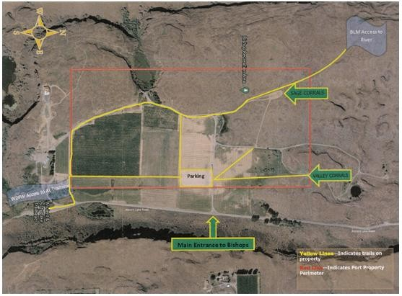
Bishop Recreation Area
On Ancient Lakes road.
$5 per night payable to the Port of Quincy. Call 509-787-3715

Camping at Dave Bishop’s place
Directions: From East Wenatchee on Hwy 28 west of Quincy near
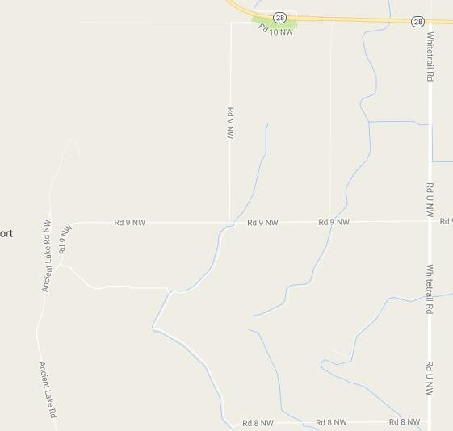
mile post 25 (just past the rest area) go south (right turn) on White Trail Road (also known as Rd U NW), right turn on Rd 9 NW, follow the road down the hill where it turns into Ancient Lake Rd.
Rest Area
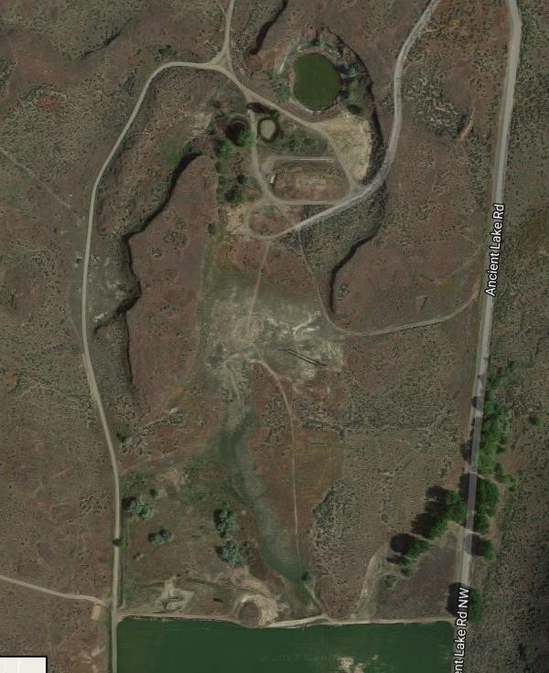
From Vantage on I-90 take Hwy 281 (about halfway between Quincy and George) turn west on White Trail Road (also known as Road 5).
Reserved camping near the pond.

