2024 Rendezvous
Table Decorating Contest
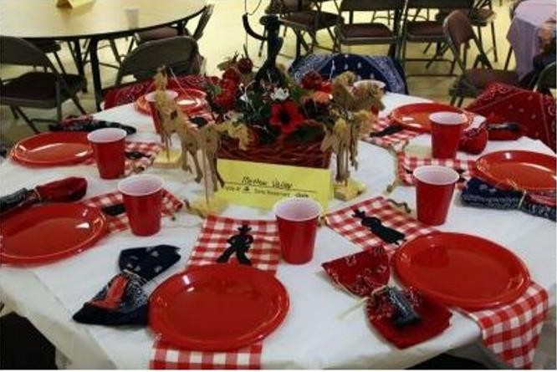
One Award given for the table that best depicts our theme:
2024 Rendezvous Theme:
“Explore More in ‘24”

Table decorating begins at 3:00pm on Saturday and must be finished no later than 4pm on Saturday.
Table decorating contest judged by:
Guest Judges

