**COME VISIT THE BCHW GENERAL STORE in the MANASTASH BUILDING**

**Cash, check and credit cards accepted!**

***Jackets, shirts, drinkware, decals, and more!***

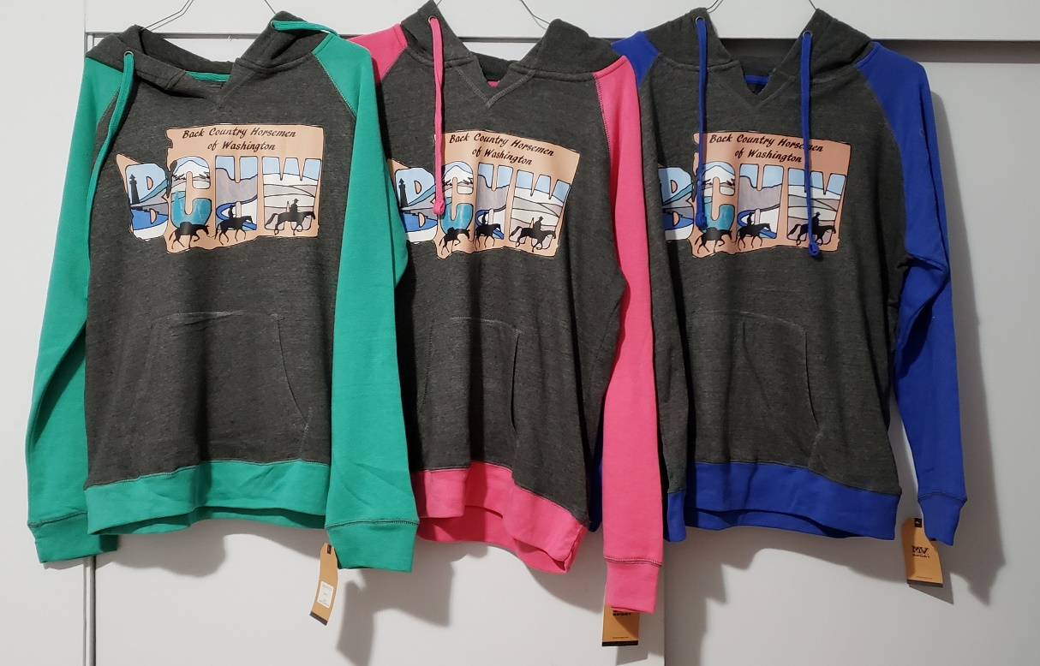

***Hats, hats and more hats!***



