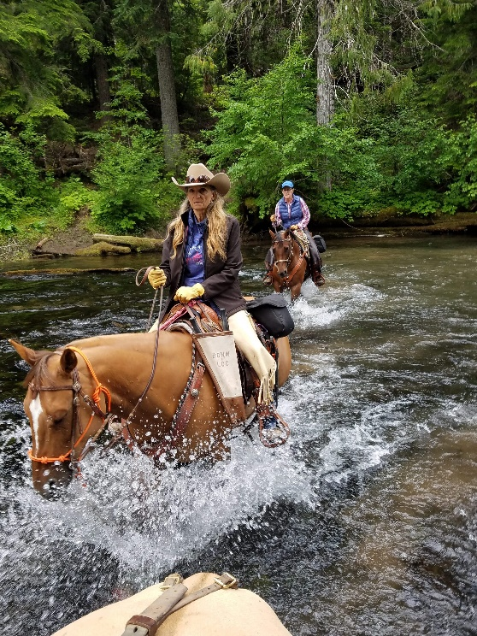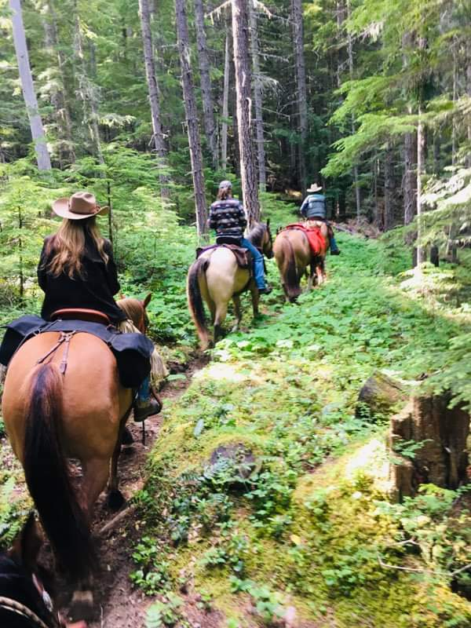

**BACK COUNTRY HORSEMEN OF WASHINGTON**

**CODY HORSE CAMP**

**REGIONAL WORK PARTY – GIFFORD PINCHOT FOREST**

**HOSTED BY – LEWIS COUNTY CHAPTER**

DATES- JUNE 12th –15TH 2025

**PRE-REGISTER ON-LINE @BCHW.ORG, CAMPING AVAILABLE**

We need volunteers for camp and trail work. Tasks include brushing/swamping, blowdown removal (sawyers needed) and cleanup of the campgrounds/sites. Something for everyone! Bring gloves, appropriate clothes. Tools, PPE, Sawyers need to bring your own saw PPE. We can also use pack stock for tools, saws, etc. for the trail work.

Information contact Tony Karniss @ [Tkarniss@gmail.com](mailto:Tkarniss@gmail.com) 360-520-5697