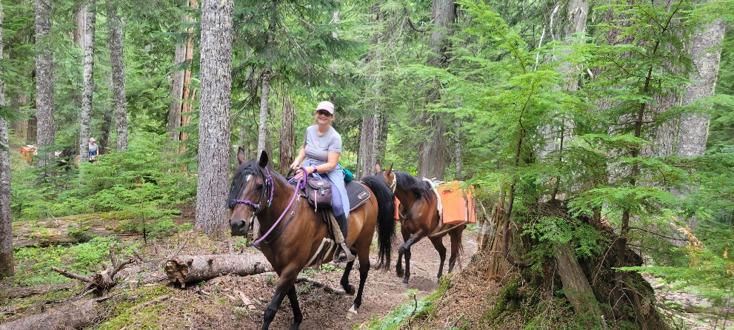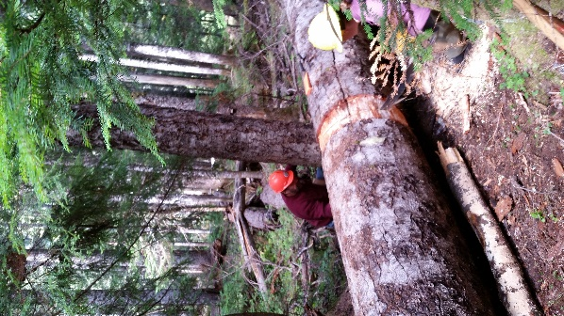

BACK COUNTRY HORSEMEN OF WASHINGTON

**LEWIS COUNTY CHAPTER**

**REGIONAL WORK PARTY-GIFFORD PINCHOT NATIONAL FOREST CARLTON CREEK TRAIL – SODA SPRINGS HC-JUG LAKE**

**DATES-JULY 13TH- 19TH 2025**

**PRE-REGISTER ON-LINE @ BCHW.ORG**

**CAMPING AREA IS LIMITED. DRY CAMP & STREAM FOR HORSE WATERING.**

**For more info contact: Tony Karniss: 360-520-5697 Email:**[**tkarniss@gmail.com**](mailto:tkarniss@gmail.com)

**Leonard Wright: 360-506-1598 Email:** [**wrightleonard00@gmail.com**](mailto:wrightleonard00@gmail.com)

**We need volunteers for camp and trail work. Tasks include: brushing/swamping, blowdown removal (sawyers needed). There is something for everyone! Bring gloves, appropriate attire and PPE. Sawyers will need to bring their own saw PPE. Pack stock is needed.**