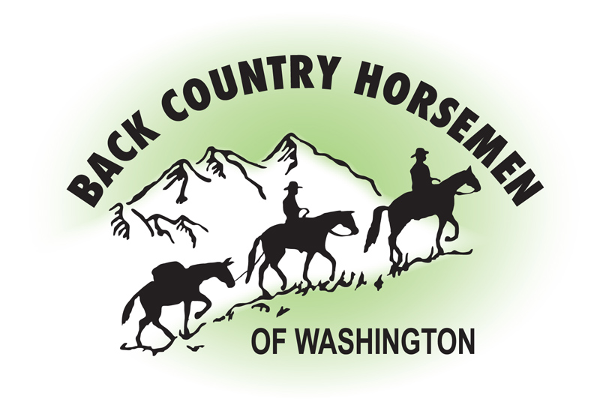
BACK COUNTRY HORSEMEN OF WASHINGTON
PO Box 1132
ELLENSBURG, WA 98926
WWW.BCHW.ORG

December 13, 2022

Superintendent
North Cascades National Park Service Complex
810 State Route 20
Sedro-Woolley, WA 98284

Regarding the Notice of Intent to Prepare North Cascades Ecosystem Grizzly Bear Restoration Plan/Environmental Impact Statement, Washington [PPWONRADE2, PMP00EI05.YP0000]

I am writing on behalf of Back Country Horsemen of Washington regarding the current intent to prepare an EIS to consider the relocation of grizzly bears into the identified North Cascades Ecosystem. The mission of Back Country Horsemen of Washington is specifically concerned with keeping trails open and accessible to the recreating public. The members of BCHW meet our stated mission goals by providing volunteer work to keep Washington State trails open for recreation. We actively partner with the National Parks and other federal and state agencies, providing pack support, skilled trail maintenance, best practices and education including a nationally recognized sawyer training program. BCHW is greatly concerned about public recreational road and trail access in the North Cascades Ecosystem and how that access could be affected with the introduction of grizzly bears. BCHW commented in 2017 opposing the Grizzly Recovery DEIS, a plan which was subsequently dropped. BCHW addressed specific alternatives in the earlier DEIS, and we expect many of our concerns to be similar when the new draft is released in the summer of 2023.

This renewed effort to restore a grizzly population in the North Cascades identifies the ESA 10(j) rulemaking option designating an experimental “essential” or “non-essential” population. If the rule is implemented in this case and additional protective regulations are established under the authority of section 4(d) of the ESA 10(j) those protective regulations would certainly enable the agencies to more easily deal with bears that travel into areas outside of core habitat and cause conflict. BCHW asserts a concern that the reverse scenario could also likely occur, where the 10(j) rule could be used to restrict, regulate, or close access to the public over a longer term if the agencies perceived a threat to recovery of a grizzly bear population.

Finally, the State of Washington RCW 77.12.35 specifically states: ”Grizzly bears shall not be transplanted or introduced into the state.” That legislation passed the Washington State Senate 44-5 and the House 96-0. Washington State Law does not currently allow for translocation, relocation, or movement of grizzly bears from outside the State of Washington and state law has not been changed to allow any of those alternatives. The interpretation that is being used with the public for this specific verbiage of Washington State Law has been to say that this only applies to Washington Dept. of Fish and Wildlife facilitating the translocation of grizzly bears. The sentence quoted above from RCW 77.12.35 is direct, concise, and specific. Importation of grizzly bears from out of the state into any area of the state is not legal.

Back Country Horsemen of Washington cannot support a grizzly recovery plan without assurances that our access to the North Cascades Ecosystem will not be adversely impacted by the proposal to reintroduce a grizzly bear population into the area. Back Country Horsemen of Washington cannot support this plan without a change to Washington State Law that would clearly allow for the importation of bears from outside of the state. As this proposal develops BCHW expects the National Park Service and the US Fish and Wildlife Service to engage in a fair nonmanipulative and truly transparent and collaborative process that ultimately meets a majority of both rural and urban Washingtonians’ acceptance.

Respectfully,
Kathy Young
Kathy Young
Public Lands Chairman, BCHW
public_lands@bchw.org

Comment ID: | 2283764-124399/5865

