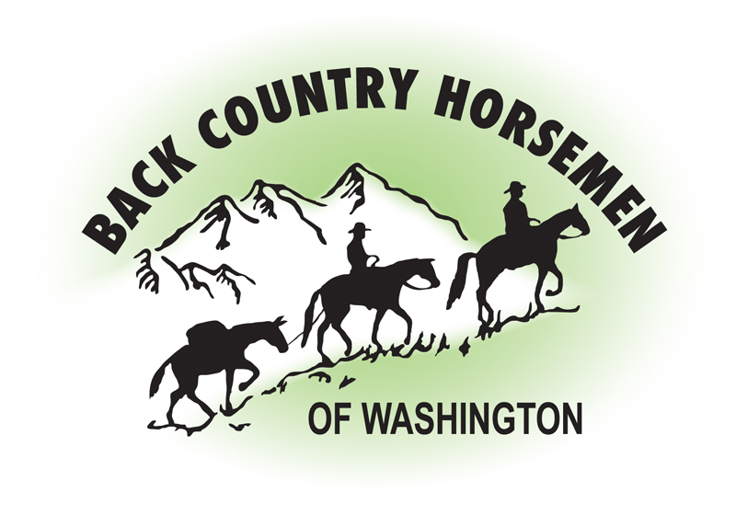
BACK COUNTRY HORSEMEN OF WASHINGTON
PO Box 1132
ELLENSBURG, WA 98926
WWW.BCHW.ORG

Superintendent
North Cascades National Park Service Complex
810 State Route 20 Sedro-Woolley, WA 98284

March 12, 2017

Thank you for the opportunity to comment on the North Cascades Ecosystem Grizzly Bear Recovery DEIS.

I am writing to address several concerns the Back Country Horsemen of Washington have with the proposal to consider the relocation of Grizzly Bears into the identified North Cascades Ecosystem.
The mission of Back Country Horsemen of Washington is specifically concerned with keeping trails open and accessible. The members of the organization met that mission goal in 2016 with over 30,000 hours of trail maintenance work done on Washington State trails. Therefore we are greatly concerned about road and trail access in the NCE and about how that access may be affected with the introduction of Grizzly Bears. The DEIS consistently states that access restrictions should be minimal, a few hours for the initial release of animals to the possibility of a few days for bear conflict management closures. If, as seems likely, the ESA 10(j) rulemaking option designating an experimental “essential” or “non-essential” population is implemented, then additional protective regulations may be established under the authority of section 4(d) of the ESA. 10(j) protective regulations would certainly enable the agencies to more easily deal with bears that travel into areas outside of core habitat and cause conflict. Our concern is that the reverse scenario could also occur, where the 10(j) rule could be used to restrict, regulate or close access over a longer term if the agencies perceived a threat to recovery of a Grizzly Bear population.

The access management sections of the DEIS also state that “other access restrictions may occur under other implementation decisions, which would be unrelated to the alternatives considered in this draft EIS plan”. Further clarification of this statement is needed as it relates to bear recovery.

The DEIS states that there should be no-net-loss of core habitat in the NCE. As a result of this priority any new trail system built, any parking lot expansion, or a mountain bike course built in a non-wilderness portion of the NCE could result in the removal of existing stock accessible trails to maintain the no-net-loss mandate.

Finally, the State of Washington RCW 77.12.35 specifically states:

”Grizzly bears shall not be transplanted or introduced into the state.”

The legislation passed the state Senate 44-5 and the House 96-0, so it is misleading to use a Defenders of Wildlife poll to say that the communities around the NCE overwhelmingly support forced reintroduction.

Additionally, in the Washington Only alternative that was dismissed from further study the DEIS states
“no translocation, relocation or movement of Grizzly Bears from outside the State of Washington should occur unless state law allows for it.” Washington State Law does not currently allow this, and state law has not been changed to allow for any translocation, relocation or movement of Grizzly Bears from outside the State of Washington. The interpretation that is being used with the public for this very specific verbiage of Washington State Law has been to say that this only applies to Washington Dept. of Fish and Wildlife actually facilitating the translocation of Grizzly Bears, even though the sentence quoted above directly from the RCW is direct, concise and specific.

It may be that our organization would support an alternative that does meet a majority of both rural and urban Washingtonians’ acceptance, but it would likely be quite different than the virtually identical action alternatives offered in this current draft. This would involve a change in state law and a fair non-manipulative truly collaborative process to achieve that change.

Back Country Horsemen of Washington cannot support any of the Alternatives B, C, or D without a change to Washington State Law that would clearly allow for the importation of bears from outside of the state. Back Country Horsemen of Washington cannot support any of the Alternatives B, C, or D without assurances that our access to the North Cascades Ecosystem will not be adversely impacted by the proposal to reintroduce a Grizzly Bear population into the area.

Respectfully,
s/Kathy Young
President, Back Country Horsemen of Washington

