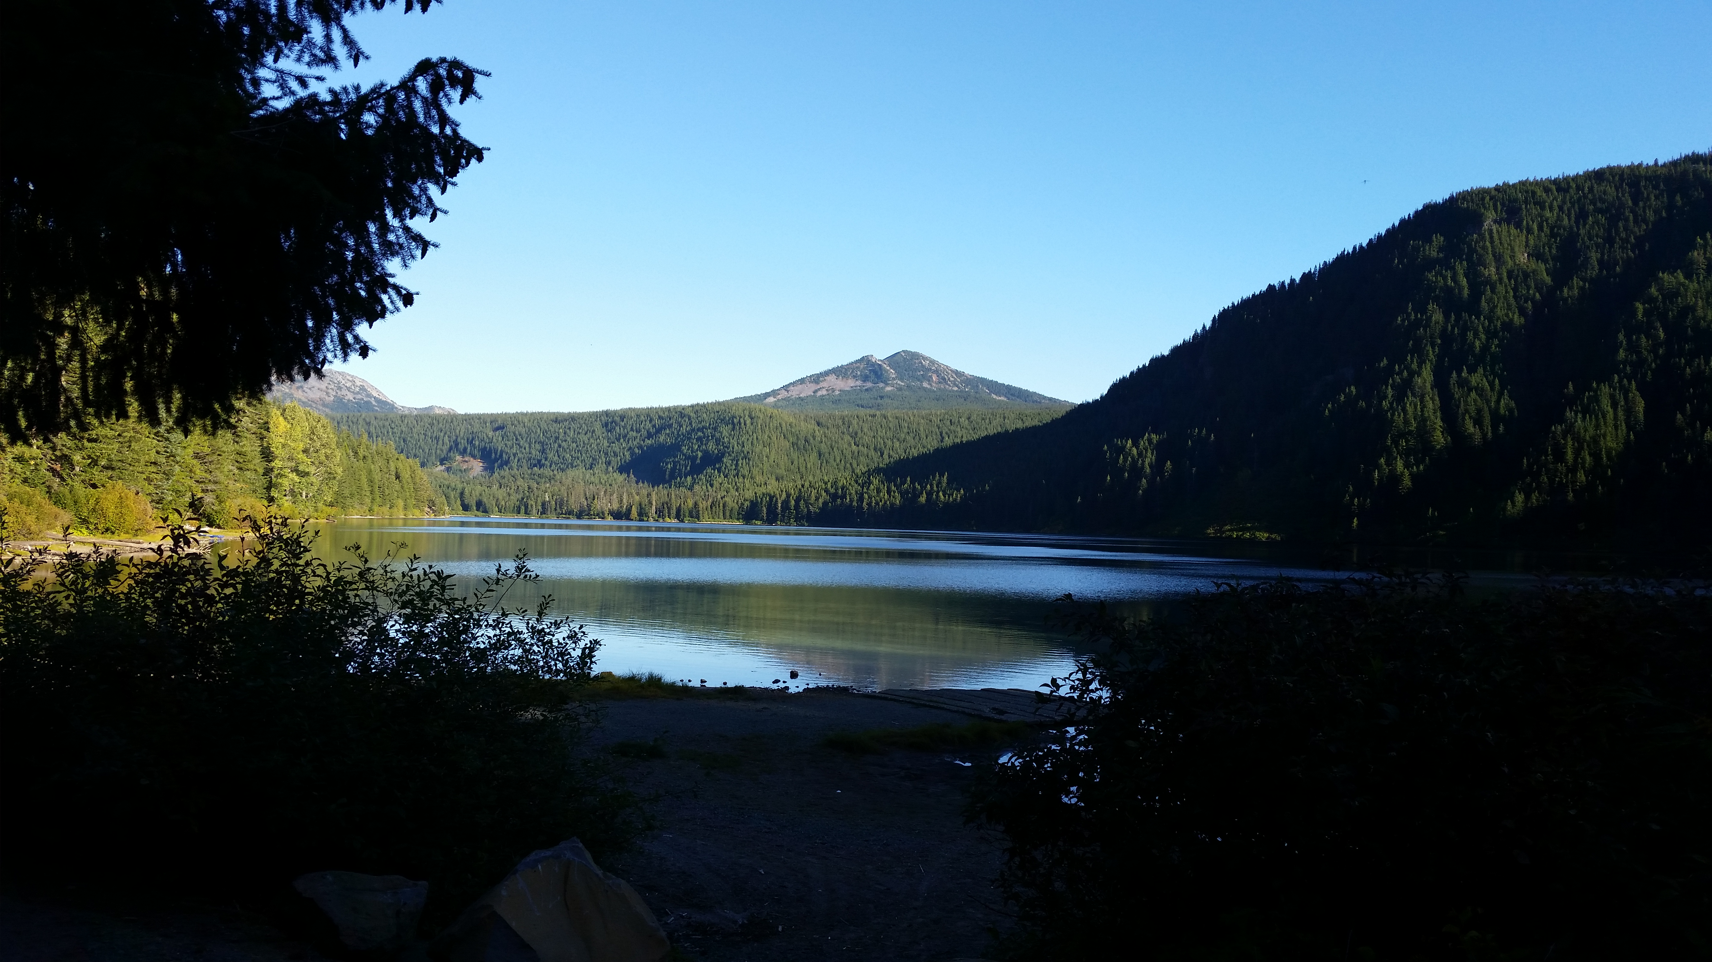

BACK COUNTRY HORSEMEN OF WASHINGTON

LEWIS COUNTY CHAPTER
  - COLLABORATE WORK PARTY AT WALUPT LAKE IN THE GIFFORD PINCHOT NATIONAL FOREST
  - WORK PARTY DATES - Thursday July 21ST – Monday July 25th
  - FOCUS WILL BE - NANNIE RIDGE TRAIL #98 REROUTE (tread work brushing and more)
  - Camping at horse camp and volunteers may choose to camp at worksite
  - Requirements:
  - Recreation Pass required – Northwest Forest Pass
  - Certified weed seed free feed on National Forest lands
  - Info: Tom Conner 360-269-3804 email@tkranch@toleldotel.com

