

**Individuals and Groups are invited to contribute.**

**Tax donation receipt provided to all donors**

**Go to:** **BCHW.ORG**

**Click on Donate Tab and scroll to bottom**



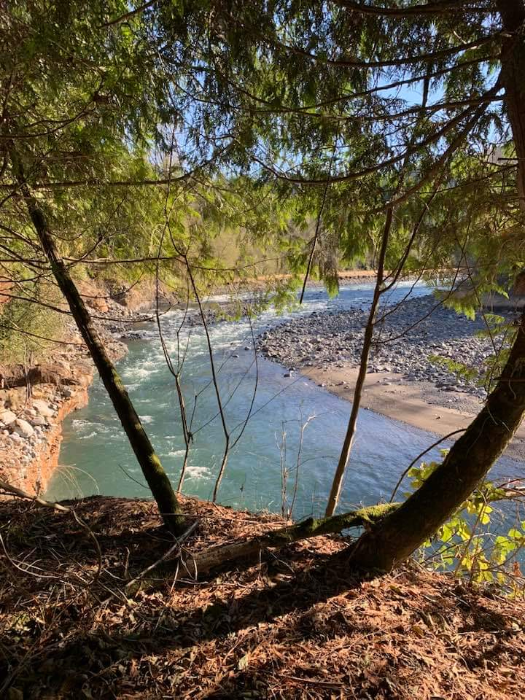

**Work Parties will be scheduled to clear trails in the area.**

**If interested contact @** **mudmtndam@bchw.org**

**Equine Parking Lot Planned for**

**Mud Mountain Dam Spring 2023**

**The parking lot will be constructed on U.S. Army Corp of Engineers managed land and will allow direct trail access from the parking lot via the Rim Trail. Tahoma Chapter of Back Country Horsemen of Washington (BCHW) Collecting donations to cover the expense of the gravel**