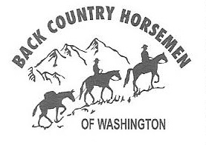 ANNUAL FUN RIDE
Mount St. Helens Chapter of BCHW
DATE: Saturday, July 20, 2024
WHERE: Kalama Horse Camp
LOTS OF RAFFLE PRIZES

Short and long loop rides available along some of the most exceptional trails
in this area. Trail maps provided on site.

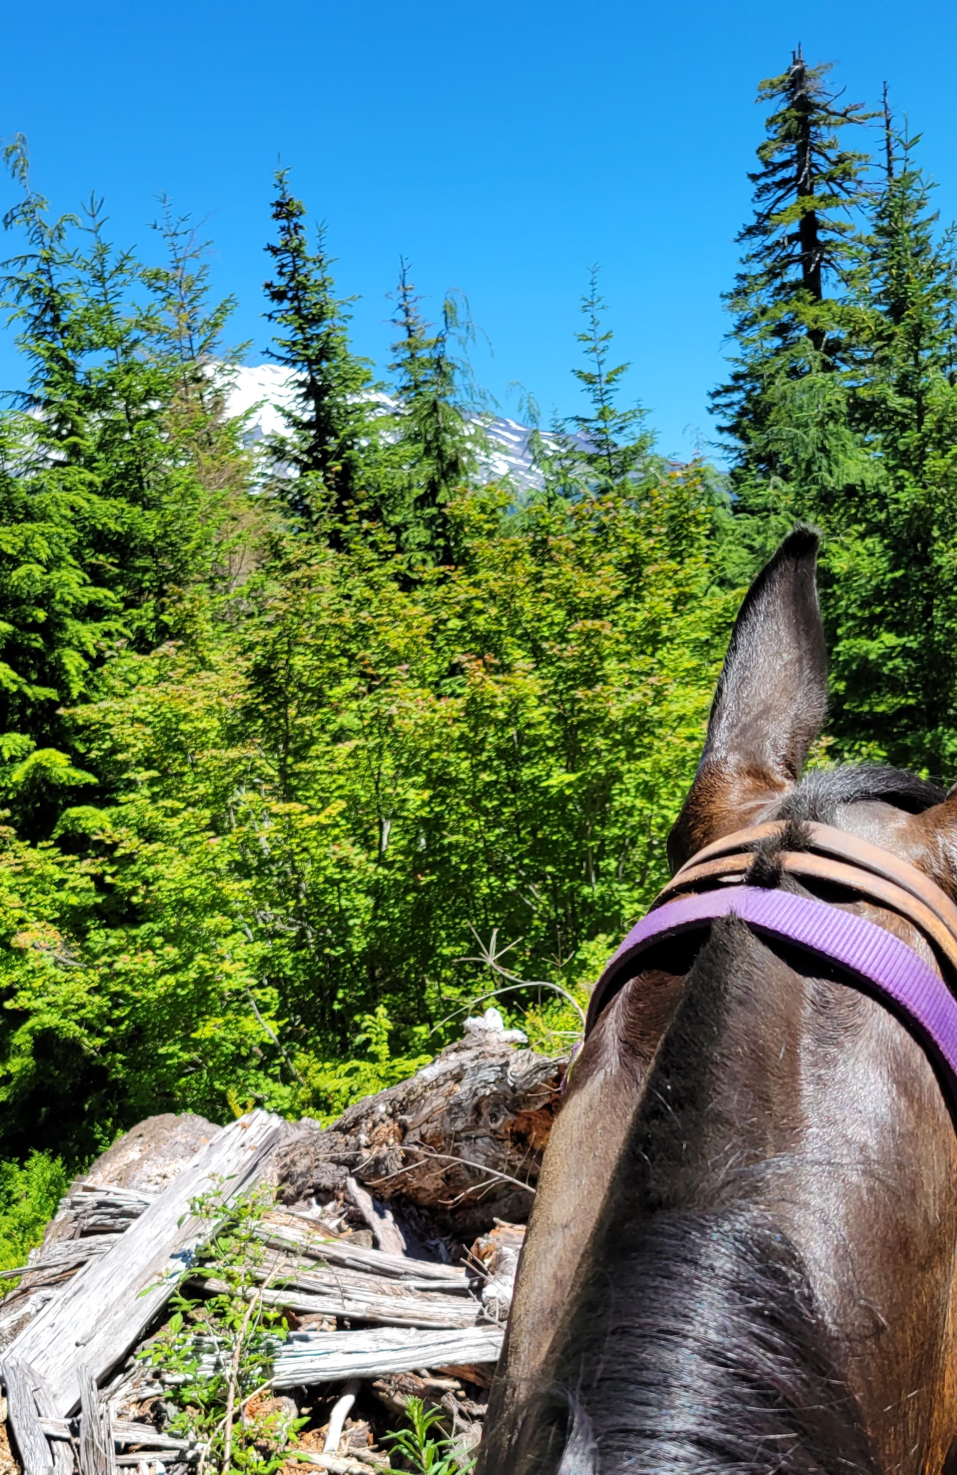 | Campsites Reservations will be available soon. $46 for two nights (Friday and Saturday).  COMPLIMENTARY BREAKFAST served at 7:00 a.m.  FIRST RIDERS OUT at 8:00 a.m. LUNCH available for $5.00. PRIZES at 3:00 p.m.  Liability waiver must be signed at the time of registration.  For more information, contact:  Brian Jansen, Email: bjbigch@aol.com  Judy Smith, Email: trailridenbuddy@yahoo.com  Jim Anderson, Email: muleman1951@gmail.com
DIRECTIONS: Take I-5 to Exit 21-Woodland. Proceed east through town on WA-503 E toward Cougar and continue east for approximately 25 miles (past Yale Park). Watch for road to the left with green road sign to Lake Merrill and Kalama Horse Camp (8100 Road). Proceed on this road for approximately 8 miles and turn right. You will see the entrance to Kalama Horse Camp. There will be volunteers available to help with parking.
NOTE: If you reach Cougar before turning onto the 8100 road, you’ve gone too far and missed the turn off.

BCHW is a 501(c)3 Non-Profit Organization
Visit us on Facebook | Back Country Horsemen of Washington Mount St. Helens Chapter
Website | mountsthelens-bchw.org

