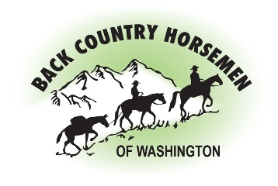

Read this document carefully before signing! It affects your legal rights. It must be signed by participants in this Back-Country Horsemen activity.
Hazards and Risks: By signing below, I acknowledge that using horses, mules, equipment and tools may expose myself and/or my child, if I am signing for a minor child, to hazard. Horses or mules can misbehave or flee. Riding in open country could result in injury caused by dangerous or unstable riding surfaces, trail obstructions of various kinds, water crossings, wild animals, poisonous plants, extreme weather conditions, and other hazards. Other risks include errors of judgement by BCHW representatives assisting with this activity, or the misuse or failure of equipment and tools provided, if any. These hazards could result in property damage, serious physical injury, or death.
Additional Provisions: I authorize BCHW to provide or obtain for me medical care as is considered necessary or appropriate and I agree to pay all costs associated with such care and related transportation. I understand I may have to pay all costs and legal fees incurred by BCHW in defending a claim or suit brought by me or on my behalf, or on behalf of the minor for whom I sign.
Acknowledgements, Assumptions of Risk and Compensation: I understand the nature of the activities I will be participating in, and their risks. I accept full responsibility for determining my own medical and physical ability to participate in the activities, and that of my mount. I take full responsibility for any injury or loss, including death, which I may suffer, arising out of these activities, whether or not described above, including the loss, injury or death of my animals.
I hereby release BCHW, its members and the land owners from any liability for any such injury or loss to me and/or my minor child, if I am signing for a minor child, whether stated above or not.
When Applicable: I affirm that I attended the BCHW Tailgate Safety Briefing and that the appropriate Job Hazard analysis and safety issues were discussed and understood.

Back Country Horsemen of Washington (BCHW) is a public charity as defined in Internal Revenue Code Section 501(c) (3). Accordingly, membership dues paid to BCHW may be treated as deductions characterized as “charitable contributions” when computing federal and state income tax obligations

