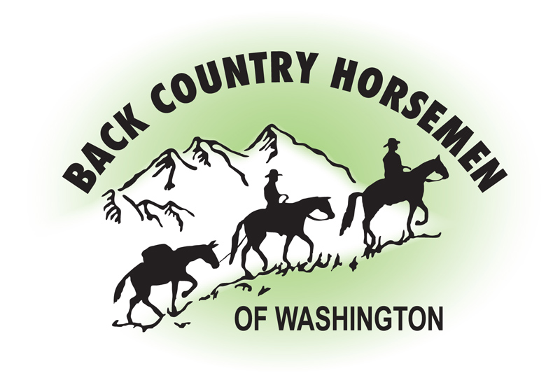
BACK COUNTRY HORSEMEN OF WASHINGTON
PO Box 1132
ELLENSBURG, WA 98926
WWW.BCHW.ORG

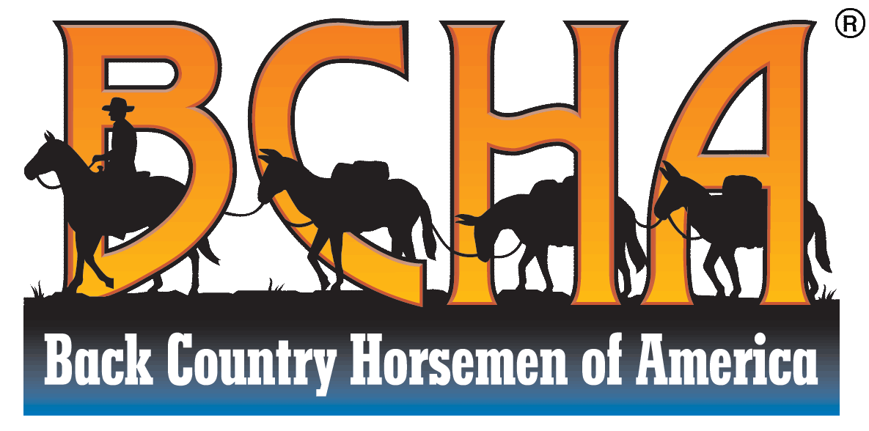

Don Striker
Office of the Superintendent
North Cascades National Park
810 State Route 20
Sedro-Woolley WA 98284 November 10, 2023

Superintendent Striker,

Thank you for this opportunity to comment on the Draft Grizzly Bear Restoration Plan / Environmental Impact Statement for the North Cascades Ecosystem

Back Country Horsemen of Washington (BCHW) is a 501(c )3 organization that is committed to maintaining access to public lands for all pack and saddle stock users. Our mission is to advocate for trail users and to assist the managing agencies of our public lands in the care and maintenance of those lands. Our members are volunteers who spend countless hours working on trails in Washington State, work that benefits many people who recreate on these lands.

BCHW shares its mission and values with Back Country Horsemen of America (BCHA) as part of the national organization consisting of 32 states.

There are vast areas of the NCE that are accessed by pack and saddle stock users. The Mt Baker Snoqualmie National Forest, the Okanogan Wenatchee National Forest including the Pasayten Wilderness, and the North Cascades National Park are all used by equestrians. BCHW has many established horse camps along the boundary of the NCE.
BCHW is genuinely concerned about how our members and other users will be able to continue to enjoy the North Cascades should a population of heavily protected grizzly bears be translocated into the region where we ride, camp and where we work with the managing agencies to maintain trails.

The DEIS presents three Alternate plans for consideration with A being No Action. Plans B and C would both implement the importation of Grizzly bears into the NCE, with the difference being use of the 10(j) rule in plan C to designate the imported animals as an experimental population, allowing more management tools to use for conflict resolution. Plan B and Plan C are deficient in their analysis of the impact on recreation and lack options for how trails can be maintained open in the presence of protections implemented to reduce human-grizzly interactions. The DEIS fails to disclose the potential impacts of the proposed action and alternatives as they might affect non-motorized recreational uses, such as hiking and horseback riding. The DEIS does speak to “tourism” and to the importance of educating the public to bear behavior and conflict avoidance. It completely lacks a management plan that supports recreation either initially, or in the future as both the human population and the Grizzly population grow. The DEIS should include consideration of how the carrying capacity of the trails, trailheads, and campgrounds will be considered without resulting in long term or permanent closures. Without that there is no way to effectively review this DEIS.

Two National Scenic Trails, The Pacific Crest National Scenic Trail (PCT), and the Pacific Northwest National Scenic Trail (PNT), traverse the identified core habitat of the North Cascades Ecosystem.

The PCT in Washington hosts multitudes of hikers and equestrians each season. These users are both distance users and day or weekend users, making the PCT one of the most populated areas around any bear ecosystem. Public use in the entire NCE likely exceeds a quarter million visits. However, the DEIS indicates that the use is insignificant. Comparing this landscape to Yellowstone National Park seems ingenuous. Back Country Horsemen of Washington has hosted several multi-day trail maintenance work events along the PCT, and regularly encounter a steady stream of users hiking or riding through daily. Use of the trail is significant and will likely result in many human-bear interactions.

The PNT, while not currently fully developed has the potential of seeing the same amount of use as the PCT over time. It also runs through the NCE as well as other bear ecosystems to the east, including the Cabinet-Yaak (CYE). The CYE has a more established population of bears but still has resulted with challenges to the very existence of the trail due to the limited number of bears in the CYE (20-40). Opposition to the National Scenic Trail in the recovering bear population area as well as the connecting landscapes between ecosystems has also been expressed by USFWS staff, the same agency putting forth the NCE proposal through which the same trail will pass.

The NPS and USFWS have pointed out that the Canadian counterparts and First Nations are preparing to release grizzly bears in the northern part of the NCE. The BC government has noted that their Recovery Plan is being developed jointly with the USFWS even though this US EIS only addresses the Washington effort. If the northern Canadian part of the NCE was the only release point, it would move the core recovery/release area away from the more densely human populated areas of Washington State. It also would be in line with Washington State law as well since no bears would be translocated directly into Washington, and there also would be predictability on how many bears are being moved into the entire NCE which overlaps both countries. We cannot support either Action Alternative without knowing more on the joint planning that is occurring with Canadian counterparts.

In closing, Back Country Horsemen of Washington, with the support of Back Country Horsemen of America, sees no alternative other than the agency must select Alternate A- No Action at this time. The current DEIS lacks any analysis of action alternatives and their potential impact on ongoing and anticipated public recreational uses in the NCE. Impacts to recreation are potentially substantive and the DEIS fails to meaningfully address and disclose these impacts. As such the DEIS fails to take the necessary hard look as required by NEPA.
Sincerely,

Kathy Young Jeff Chapman
Public Lands Chairman, BCHW Legislative Chairman, BCHW
public_lands@bchw.org legislative@bchw.org
www.bchw.org www.bchw.org

Mark Himmel
Chairman
Back Country Horsemen of America
www.bcha.org

