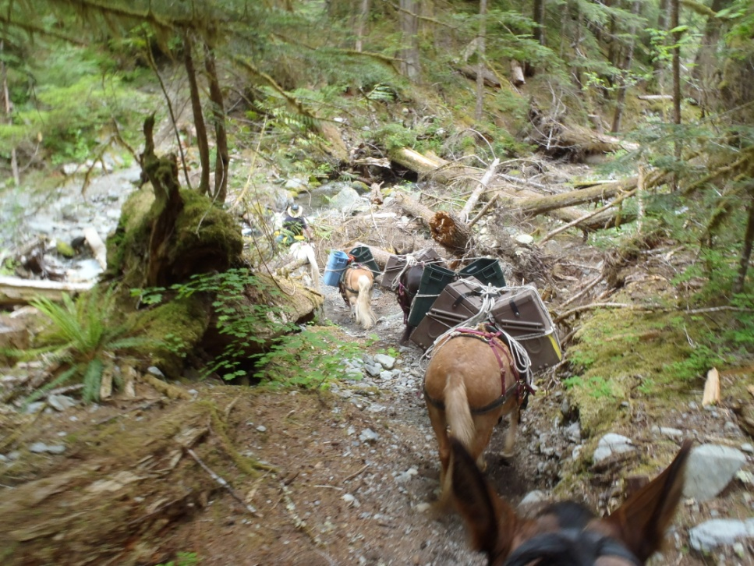
"Packing Workshop with the Haefligers"
So you want to give horse or mule packing a go! Here is a great chance to visit and discuss this idea with folks that have done their share of exactly that. We are willing to help you get started. However, if you are already on the way, there will be some new additional tips and tricks that may help. We will show hands-on, how to tie on the many different packing boxes and carriers that have helped us move camps and tools for years, while packing into the Olympic National Park. You will leave here with a new way to tie a diamond hitch (both single and double), that is almost impossible to forget. Dress for the weather; bring a chair and your lunch. Coffee is supplied. We are looking forward to seeing you and sharing our knowledge, skills, and experiences.
This is a Free program sponsored by the Back Country Horsemen of Washington
April 23, 2022. Starting at 10AM.
400 SE Kalium Dr, Shelton WA 98584
360-427-4297
For more information about us, check out www.mtcanaryco.com
"Packing and camping with your mules or horses is great! However there must be something greater or the Good Lord would have kept it for himself!"

