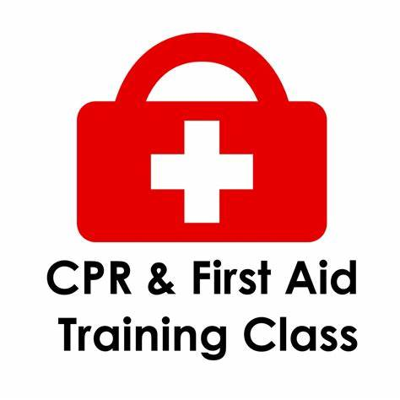
Our First Aid / CPR Certifications will be held at Rendezvous the weekend of March 18-20, 2022 in Ellensburg at the Kittitas Valley Event Center.
Two class choices:
Friday March 18th, 2022 from 1:00pm – 5:00pm
Or
Saturday March 19th, 2022 from 8:00am – 12:00pm
These classes will be taught by Lt. Roy Varney
There will be a max of 10 students per class

If you want to attend there will be a $10 registration fee charged in advance. IF you attend the class you will be refunded $5 unless you wish to donate it.
To receive a FA/CPR Card for your wallet there will be an additional fee when you order it online!
A wallet card is not required for Sawyer Certification.

