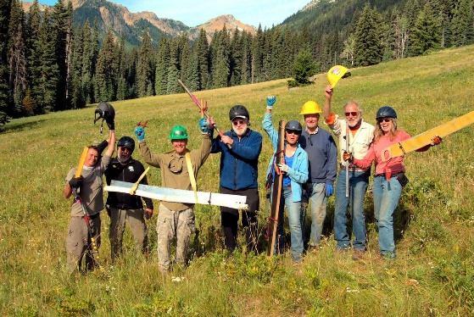T
This first work party is mainly on foot with some pack support. This is perfect for those who don't have stock. We will work up to the snow on Jack Creek Trail and no more than 3 miles up the trail. On the Trout Trail, which is in the sun, we can get farther but no more than 4 miles. Base of operations is at Black Pine Horse Camp. The schedule will be as follows:
Sunday May 29, 2022 arrive at Black Pine Horse Camp
Have a safety meeting, and sign paperwork
Organize tools
Monday May 30 Divide into crews:
Log out Jack Pine connector trail
Start logging Jack Creek Trail
Start logging Trout Trail
Stay in Camp after work
Make a plan for Tuesday work
Tuesday May 31
Start work where we left off Monday
When the work party is over, we will make plans to continue logging for the next work party base on based on how much we got done. The next work party will involve more stock. After work, those who live close- drive home.
Wednesday June 1
Those who live far- drive home
We will report to Wenatchee River Forest Service Ranger District the work that was accomplished!

Thank you!!

