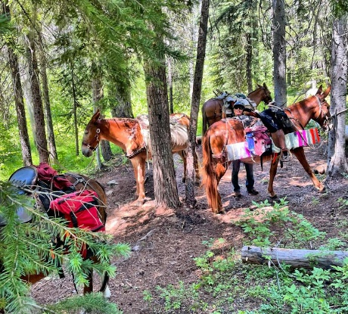
The 4th of July Week, will be our first stock packing/camping in the high country work party for the season. The trail to Cradle Lake is usually clear of snow by then and usually presents with some challenging big logs! We live for this! If there is time, we will continue logging west on Meadow Creek Trail. This requires fit stock!
Sunday July 3 - drive into Black Pine Horse Camp
Have a safety meeting
Organize tools with consideration of pack stock
Monday July 4 - Pack into the Meadow Creek Hunter Camp-celebrate the 4th with a tasty Mountain House Dinner and clang pans!
Tuesday July 5- Start logging the trail to Cradle Lake
Wednesday July 6 - Continue logging where the logging fairies take us
Thursday July 7 - same
Friday July 8 - Pack out to Black Pine Horse Camp
Saturday July 9 - drive home
Report to Wenatchee River Ranger District work that was accomplished
Fine tune tread work projects for the Big Work Party for final tool planning

