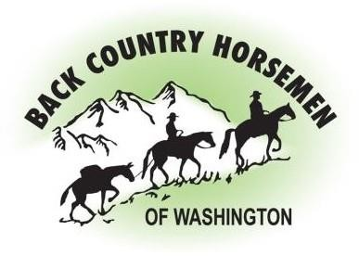
BACK COUNTRY HORSEMEN OF WASHINGTON
PO Box 1132
ELLENSBURG, WA 98926

WWW.BCHW.ORG

BCHW Chapter Grant Program Applications
Please fill out the form below, to the best of your ability, and email bchwchaptergrants@bchw.org

Project Name:
Chapter:
Chapter Lead/Contact: Include the name, email address and phone number for the project leads (people who are actively involved in planning the project and have a good grasp on all project details).
Project Location:
Project Land Manager: Who currently owns/manages the land? If privately owned, include landowner contact info.
Project Description: Include a brief description of the project including current plans and work that has already been accomplished at the project site. The project description should include measurable actions that will be completed, if funded. Examples below:
- Miles of trail maintained, relocated, or restored.
- Feet of puncheons/boardwalks that will be maintained, relocated, or restored.
- Feet of turnpikes that will be maintained, relocated, or restored.
- Miles of gravel road that will be maintained, relocated, or restored.
- Number of campsites that will be installed, maintained, or restored.
- Number of trailheads that will be installed, maintained, or restored.

Small Tools needed:

Funding Need Estimate: Include an estimate of how much funding you need to complete this project. Please include as much detail as you can.
Partners (if any):
Timeline: When do you want to do this project? Are there only certain times of year you can do this work (snowpack, etc.).
Existing Funding: Have you already obtained some funding to do this work? Do you have existing grant funding for working on this project?
Pre-Photos: Please attach (or send) a few photos of the project site.
Post-Photos: Please supply a report and photos after the project is complete.

