Please consider joining us as a member or at a work party and be a part of all the great things we do for our trails in the back country as well as in the front
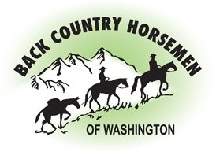
country!!

BCHW.org

Please consider joining us as a member or at a work party and be a part of all the great things we do for our trails in the back country as well as in the front
country!!

BCHW.org

Please consider joining us as a member or at a work party and be a part of all the great things we do for our trails in the back country as well as in the front
country!!

BCHW.org

Please consider joining us as a member or at a work party and be a part of all the great things we do for our trails in the back country as well as in the front
country!!

BCHW.org

Please consider joining us as a member or at a work party and be a part of all the great things we do for our trails in the back country as well as in the front
country!!

BCHW.org
Please consider joining us as a member or at a work party and be a part of all the great things we do for our trails in the back country as well as in the front
country!!

BCHW.org

Please consider joining us as a member or at a work party and be a part of all the great things we do for our trails in the back country as well as in the front
country!!

BCHW.org

Please consider joining us as a member or at a work party and be a part of all the great things we do for our trails in the back country as well as in the front
country!!

BCHW.org

Please consider joining us as a member or at a work party and be a part of all the great things we do for our trails in the back country as well as in the front
country!!

BCHW.org

Please consider joining us as a member or at a work party and be a part of all the great things we do for our trails in the back country as well as in the front
country!!

BCHW.org

