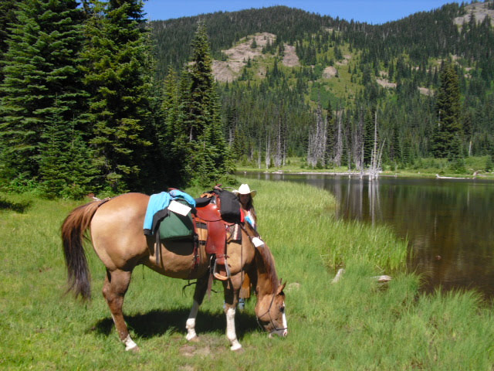

BACK COUNTRY HORSEMEN OF WASHINGTON

LEWIS COUNTY CHAPTER

Regional Work Party-Gifford Pinchot National Forest
NANNIE RIDGE RE-ROUTE
WALUPT LAKE HORSE CAMP AND NEAR WORK SITE CAMPING

DATES -WEDS AUGUST 9TH – SUNDAY AUGUST 13TH

PRE-REGISTER ON-LINE AT BCHW.ORG
FOR MORE INFO CONTACT: TOM CONNER 360-269-3804 Email: tkranch@toledotel.com
OR TONY KARNISS @ 360-520-5697 EMAIL: tkarness@gmail.com
WE NEED VOLUNTEERS TO CAMP AND TRAIL WORK. TASKS INCLUDE:
BRUSHING /SWAMPING, BLOWDOWN REMOVAL AND TREAD WORK. WE WILL NEED SAWYERS AND VOLUNTEERS WITH PACK STOCK. PLEASE BRING PPE (SAWYERS WILL NEED SAWYER PPE), BRING GLOVES AND APPROPRIATE ATTIRE TO WORK. THERE IS SOMETHING FOR EVERYONE

