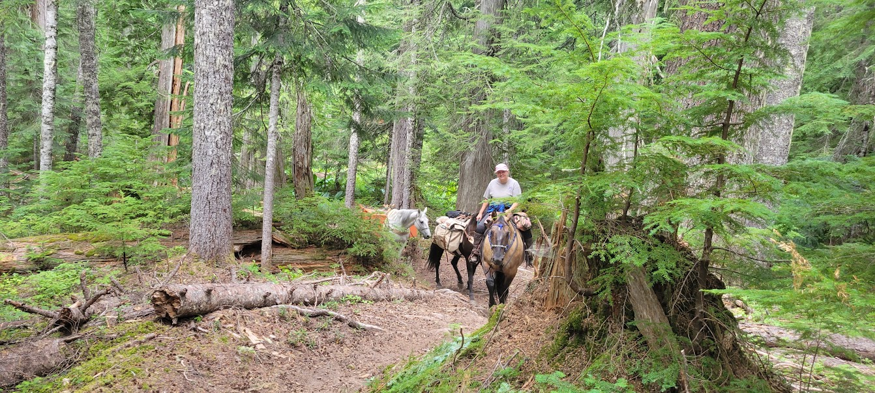

BACK COUNTRY HORSEMEN OF WASHINGTON
LEWIS COUNTY CHAPTER
REGIONAL WORK PARTY-GIFFORD PINCHOT NATIONAL FOREST CARLTON CREEK TRAIL – SODA SPRINGS HORSE CAMP
DATES- MONDAY JULY 17TH – SUNDAY JULY 23^{RD,} 2023

PRE-REGISTER ON-LINE @ BCHW.ORG
CAMPING AREA IS LIMITED. DRY CAMP & STREAM FOR HORSE
WATERING. BRING YOUR OWN WATER.
For more info contact: Tony Karniss: 360-520-5697 Email: tkarniss@gmail.com
We need volunteers for camp and trail work. Tasks include: brushing/swamping, blowdown removal (sawyers needed). There is something for everyone! Bring gloves, appropriate attire and PPE. Sawyers will need to bring their own saw PPE.
Pack stock is needed.

