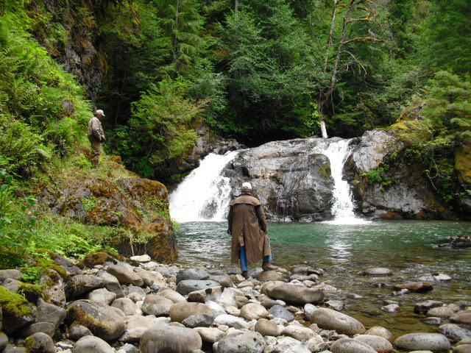

BACK COUNTRY HORSEMEN OF WASHINGTON
LEWIS COUNTY CHAPTER
REGIONAL WORK PARTY -GIFFORD PINCHOT NATIONAL FOREST
GREEN RIVER HORSE CAMP
DATES- WEDENSDAY JUNE 21ST- SUNDAY JUNE 25TH

PRE-REGISTER ON-LINE AT BCHW.ORG
CAMPING AREA AVAILABLE WITH A NEAR BY STREAM.
FOR MORE INFO CALL TONY KARNISS: 360-520-5697 EMAIL: tkarniss@gmail.com
LEONARD WRIGHT: 360-506-1598 EMAIL: wrightleonard00@gmail.com
We need volunteers for camp and trail work. Tasks include: brushing/swamping,
Blowdown removal (sawyers needed). There is something for everyone! Bring
gloves, appropriate attire and PPE. Sawyers will need to bring the own saw PPE.
Packing stock is needed. There will be some bridge repair to do.

