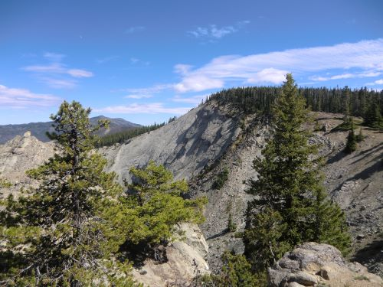
BCHW Haney Meadow Regional Work and Ride

Ken Wilcox Horse Camp June 30-July 5th

Ken Wilcox Horse Camp at Haney Meadows is located near Blewitt Pass about 8 miles off Highway 97. The camp is at about 5500’ has a long-storied past with BCHW. A fire in 2012 damaged much of the camp area and surrounding trail system. BCHW hosted state work parties in 2013 and 2014 replaced bridges, reopened trails and replaced many of the trail signs. Cathy Nelson and Trail Dusters of BCHW has sponsored road, trail and campground improvements each year since. Recent years with major wind events have brought much of the dead standing timber down. Combined with new growth overtaking the trails much of the trail system needs maintenance.

Come and help restore and ride this great and scenic place with Sponsoring Chapters:
Tahoma, Ellensburg Valley, Trail Dusters, Wenas Valley, Mt. St. Helens and Wenatchee
- Camping sites with over flow area. Hi-line or tie to trailer, stock water available no
potable water. Weed seed free hay required (USFS). No grazing allowed in the meadow
- Certified BCHW Sawyers only, must be current on first aid CPR and provide their own
saws and PPE
- Other work includes brushing, tread work also needed improvement in camp Hitching
rails meadow fencing and signage replacement.
- We will have a good supply of tools for most projects also a limited supply of hard hats. If you have a favorite trail tool, please feel free to bring it. Please make sure to have plenty of water and sturdy gloves.
- This project provides meals starting Friday (am) June 30 thru Wednesday (am) July 5 for all attending.
- Great trail riding with easy to moderate system of trails. Green Trail Map #210 would be
a good map of the area Green Trail #211s if attainable is even better.
- Pre-Register required, Registration ends June 01, 2023 Driving directions to be sent on request
- Ed LETCHER 206-478-9331 edtrailblazer@gmail.com
Ken EVANS 1-360-903-1S92 pkevans@tds.net

