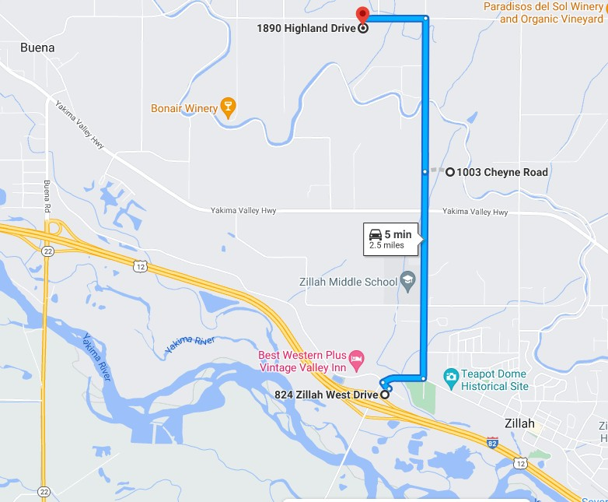

**Base Camp**

**“Velen Camp”**

**Camp**

**Exit 52**

**BCHW Wine Ride 2022**