BACK COUNTRY HORSEMEN OF WASHINGTON
LEWIS COUNTY CHAPTER
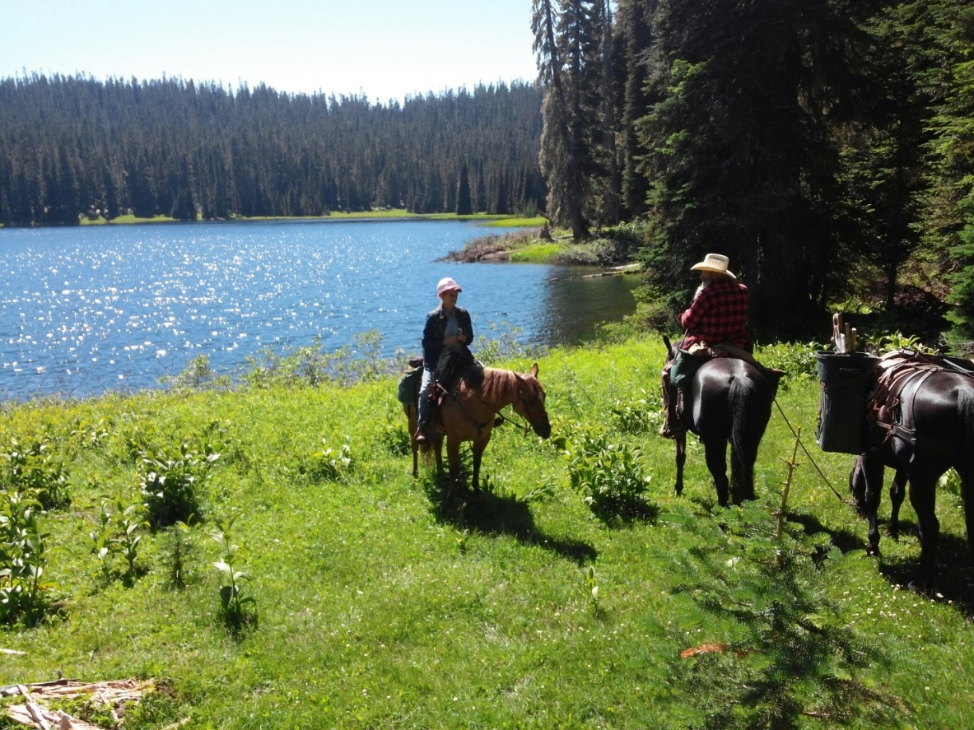
REGIONAL WORK PARTY- WENATCHEE NATIONAL FOREST SODA SPRINGS, COWLITZ HORSE RAMP & SURROUNDING TRAILS
WILLIAM O. DOUGLAS WILDERNESS
- DATES: WEDNESDAY AUG 10TH – SUNDAY AUG 14th *REGISTER ON-LINE*
- CAMPING-DISPERSED OR WILDERNESS SETTING, NO MEALS PROVIDED
- PERMITS: NO PARKING FEE AND WILDERNESS REGULATIONS APPLY
Contact Name(s): Tony Karniss or Slim Mardock
Phone Number: 360-520-5697 Email: tkarniss@gmail.com (Tony)
Phone Number: 360-520-5588 Email: Almardock56@gmail.com (Slim)

