Used Tack Sale

Back Country Horsemen of Washington Annual Rendezvous

Used Tack ~ Vendor Booths ~ Free Classes & Demonstrations

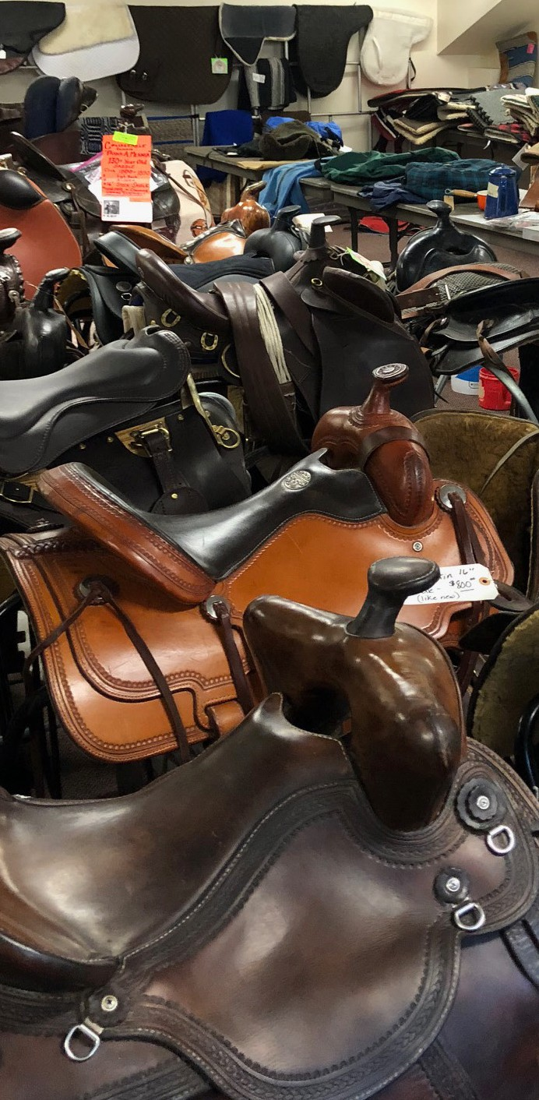

**Mark your calendars for Kittitas County’s largest used tack sale!**

**March 17th - 19th, 2023**

**Friday & Saturday 9 am - 5 pm**

**And Sunday 9 – 11 for sales and tack pick up.**

**Kittitas Valley Event Center at the Ellensburg Fairgrounds**

**512 N Poplar, Ellensburg, WA**

In addition to the sale, browse vendor booths offering special show prices:

* metal art
* alpaca products
* jewelry, clothing & hats
* arts & crafts
* leather work
* Cavallo’s horse boots

**OPEN TO THE PUBLIC!** While you’re there, come learn more about the Back Country Horsemen of Washington and attend free demos and classes. **ALL TACK MUST BE CLEAN AND TAGGED WITH FIRST AND LAST NAME, PRICE AND PHONE NUMBER. WE WILL NOT ACCEPT TACK THAT IS NOT TAGGED! This is a consignment sale, so we will take care of selling it for you and keep 15% of the sale price as part of our fundraising effort.**

**Tack sale info, contact Linda Riley**

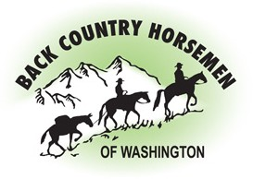**Text me 360-421-0992 (preferred)**

[rosie1400@yahoo.com](mailto:rosie1400@yahoo.com)

**More info about all**

**Rendezvous activities at**

**BCHW.org**