2023 Rendezvous Table Decorating Contest
2022 Winning Chapter was Wenas Valley!
Below is one of three tables they decorated in a progressive theme.

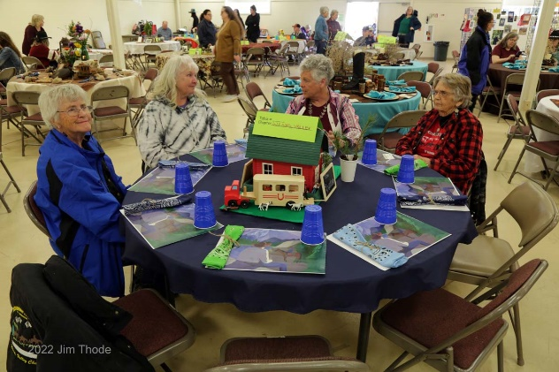

First, Second and Third place awards will be given for the 2023 Rendezvous Theme of, “Not All Who Wander Are Lost”!
Tables must be decorated one hour prior to dinner on Saturday.
Individual tables to be judged!
The Table Decorating Contest will be judged by the 2022 Contest Winners.
The Wenas Chapter!!

