2021 BCHW Wine Ride
Oct. 30, 2021
Hosted by
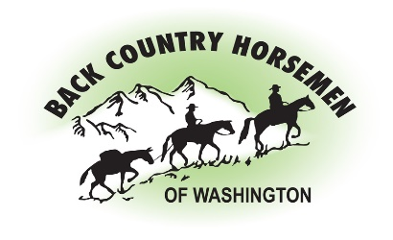

DIRECTIONS TO 1890 HIGHLAND DRIVE

Traveling East on I-82 (from Seattle/Ellensburg/Yakima), take Exit 52 toward Zillah. Turn Left on Meyers Rd. Take the 2nd Left onto Cheyne Road. Continue on Cheyne past the school and through stop sign at Yakima Valley Hwy. Continue North approximately 1-mile, then turn left on Highland Drive. Go just under ½ mile to just past 1890 Highland Drive to the very next driveway on the South side.

Traveling West on I-82 (from Walla Walla/Tri-Cities/Sunnyside), take Exit 52 toward Zillah. Turn Right on Meyers Rd. Take the 2nd Left onto Cheyne Road. Continue on Cheyne past the school and through stop sign at Yakima Valley Hwy. Continue North approximately 1-mile, then turn left on Highland Drive. Go just under ½ mile to just past 1890 Highland Drive to the very next driveway on the South side.

For more info about the Wine Ride go to bchw.org

About BCHW Back Country Horsemen of Washington
(BCHW) is a state-wide, nonprofit organization made up of 2000 members in 31 chapters across the state. BCHW is dedicated to keeping trails open for all users, educating horse users in Leave-NoTrace practices, and providing volunteer service to public land managers and agencies. Thank you for your generous support!

